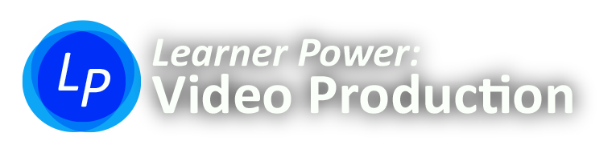
Your Name: ________________________________________ Today’s Date: __________
Permission Form

We do several special things in this class to promote quality student work and to improve instruction. All of them are optional. Please write “Y” or “N” next to each item if you wish to participate.

Please Write “Y” or “N” in the box next to each statement
☐ | I give the school permission to publish my work in educationally appropriate ways. This includes online services such as YouTube. My work could also be shared with the public on signs or through the media. My work could also be submitted to contests, festivals, and other competitions. I agree that if my work is published then it might include my name and honors or awards that I have won.
☐ | I give the school and other students permission to use media of me in educationally appropriate ways. Media of me might include photos, videos, and/or sound recordings. I understand that educationally appropriate ways may include publishing photos and videos of me on the Internet. I give permission for this published media to include my face, my voice, and / or my name.
☐ | The teacher in this class collects anonymous student data to improve instruction. This anonymous data includes retention rates, test performance, early finishing rates, and student opinions about the learning tools. I give the teacher permission to collect anonymous data from me in this class.
☐ | This course includes optional online interactions. The purpose of these interactions is to simulate the kinds of online discussion that digital media professionals might encounter in the working world. I agree to engage in online communication that follows existing school policies, is professional, and does not harass or bully anyone else.
☐ | I am 18 or above.

Student Please Sign Here to Agree: _______________________________________________________

Parent / Guardian Signature (if under 18) : _________________________________________________

