shot subject: e.g. Julie, car, dog, hand, etc. | shot verb: e.g. walks, talks, goes, drives, etc. | shot purpose: e.g. to establish, to show, to explain, to cover, to reveal, to connect, etc. |  |  | Learner Power Storyboard
 |  |  |  |  | scene name | shot #
 |  |  |  |  | production notes (props, lights) |  if done
drawing: sketch this shot using the rule of thirds. Stick figures are fine. |  |  | duration: in seconds |  | synchronous sound: dialogue, interview, SFX
 |  |  | type: WS, MS, MCU, CU, ECU, POV, OSS, 2-S | camera angle: Low, S, or High
 |  |  | asynchronous sound: music, background audio, voice-over, foley
camera motion: e.g. zoom (wide/tight), pan (left/right), tilt (up/down), dolly (in/out), pedastal (up/down), track (subject), fly, glide
camera control: e.g. tripod, handheld, dolly, helmet mount, etc.

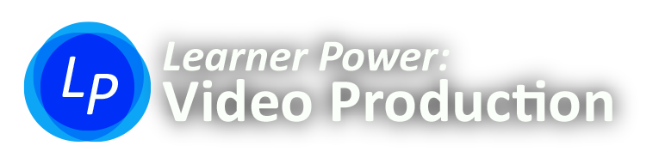
© Pasha Souvorin 2013

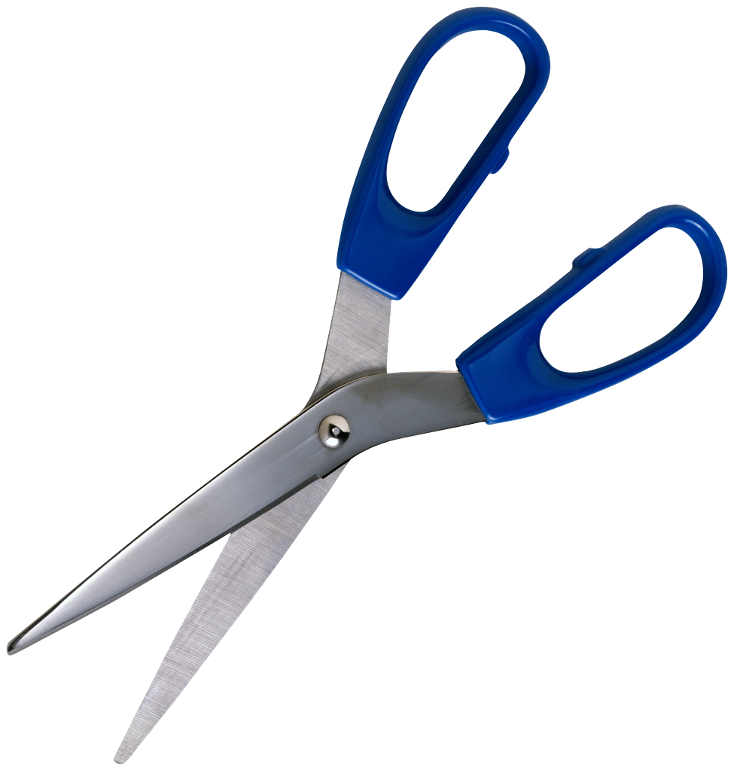
shot subject: e.g. Julie, car, dog, hand, etc. | shot verb: e.g. walks, talks, goes, drives, etc. | shot purpose: e.g. to establish, to show, to explain, to cover, to reveal, to connect, etc |  |  | Learner Power Storyboard
 |  |  |  |  | scene name | shot #
 |  |  |  |  | production notes (props, lights) |  if done
drawing: sketch this shot using the rule of thirds. Stick figures are fine. |  |  | duration: in seconds |  | synchronous sound: dialogue, interview, SFX
 |  |  | type: WS, MS, MCU, CU, ECU, POV, OSS, 2-S | camera angle: low, S, or high
 |  |  | asynchronous sound: music, background audio, voice-over, foley
camera motion: e.g. zoom (wide/tight), pan (left/right), tilt (up/down), dolly (in/out), pedastal (up/down), track (subject), handheld, fly, glide
camera control: e.g. tripod, handheld, dolly, helmet mount, etc.

© Pasha Souvorin 2013

